Exercise lecture 5 Switch Mode converters
1 Electrical circuit model
1.1 Electrical circuit model for capacitor(2.2 mF)
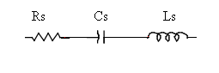

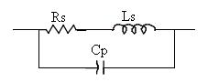
1.2 Electrical circuit model for inductor(1.5mH) with laminated core

2. Measured model parameters
Capacitor
At Low frequency range impedance of the capacitance dominates, at mid range frequencies the resistance dominate at high frequencies the inductor.
Z
C
L
R
Freq

At 20 Hz: Z= 0.8 Ohm. Therefore the capacitance is 1.989 mF
At 100Hz: Z=4 Ohm. Therefore the capacitance is 1.989mF
In average the capacitance value is 1.989mF, that is approximately equal to the specified value of 2.2mF.
At constant impendance region( mid frequencies) the impedance measured is equal to the ESR value equals to 35 mOhm.
The inductance dominates at high frequencies, and the impedance corresponding to the inductor obtained as at 400 Khz equals to 0.5 Ohm, therefore the inductance equals to 0.1989 uH.
Inductor
At Low frequency range impedance of the resistance dominates, at mid range frequencies the inductance dominates, and at high frequencies the effect of the parallel capacitance reduces the impedance.
As the measurement equipment does not works with frequencies below 20 Hz, we could not produce an DC current, therefore we could not get the values for the resistance.
The sweeping of the frequency was done from 20 Hz to 2 MHz, the inductance value since it is a laminated core, accurate value are obtained below 1 Khz, as the core losses affect the impedance beyond that frequency.
Therefore we have obtained at 100 Hz and 1 KHz the impedance are 1 and 10 Ohms respectively, therefore the inductance average value equals to 1.6 mH, which is approximately equal to the specified value of 1.5 mH.
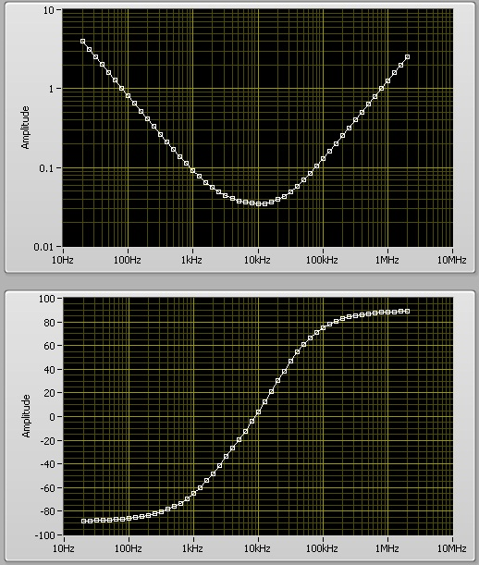
3. Plot of Impedance and Angle vs Frequency

Capacitor impedance and angle vs frequency
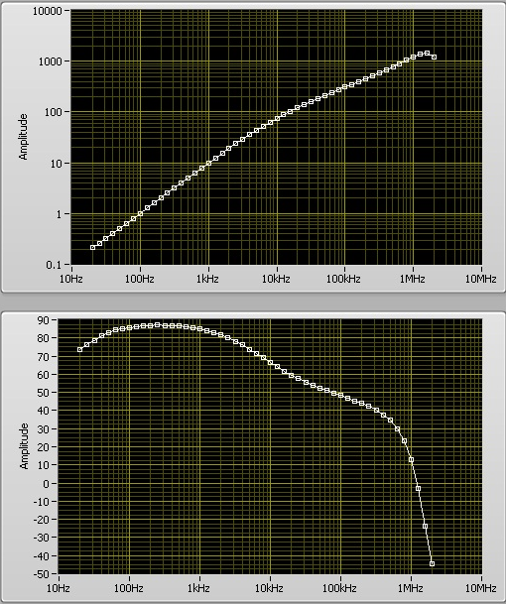
Inductor impedance and angle vs frequency

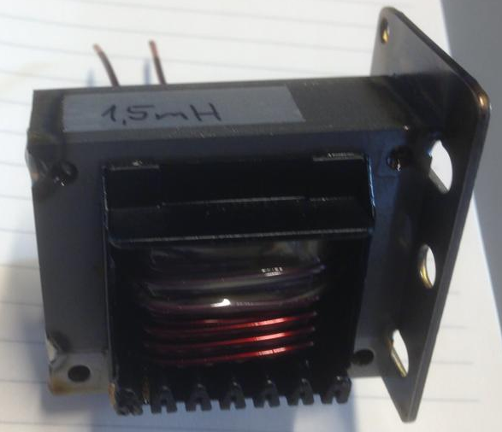
4. Pictures of the components.
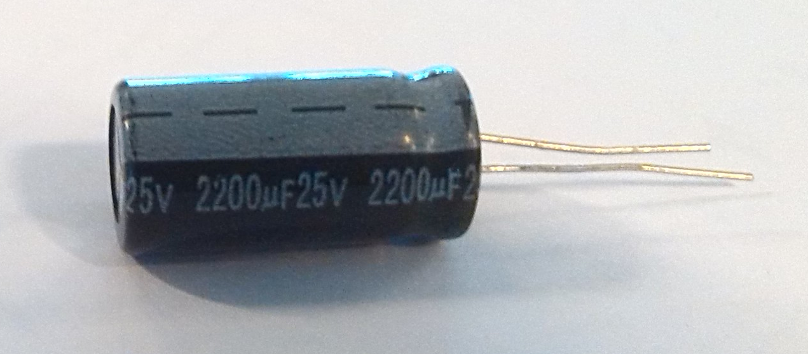

5. Picture of the measurement setup
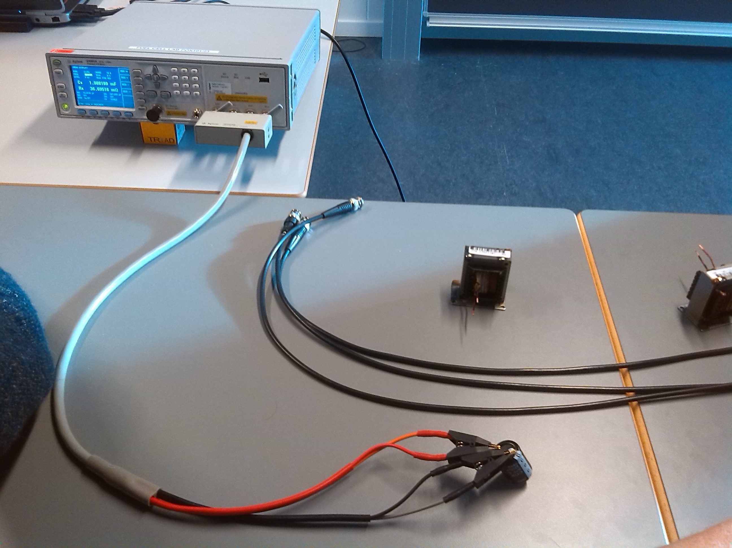
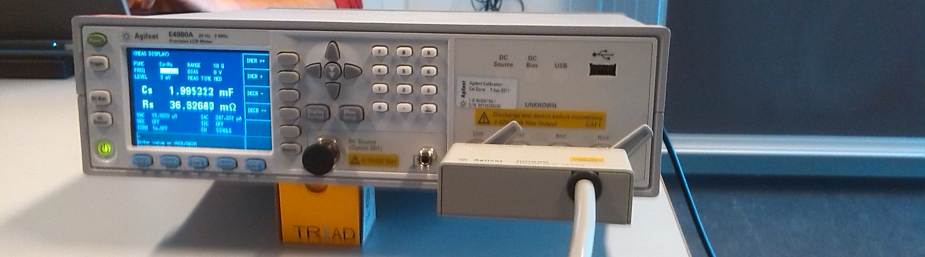

6. Instruments used.
The equipment used to make the measurements is the LCR meter of the type Agilent E4980A.

Done by group Intro760.
Ariya Sangwongwanich
Unnikrishnan Raveendran nair
Pramod Kumar Prasobhu
Marcos Rejas Haddioui

